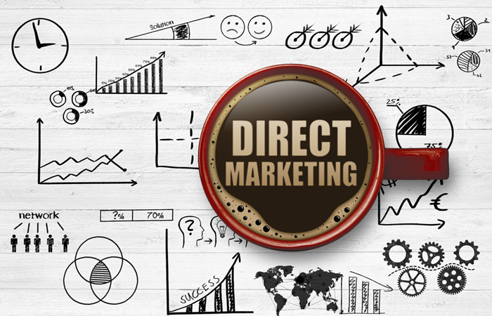

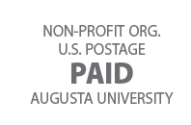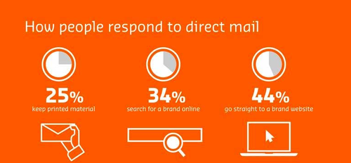

1*2*345678**ABC 0-VWXYZ 98765



Bernadette Avery

23 Henery Street

Witchita, KS 67202

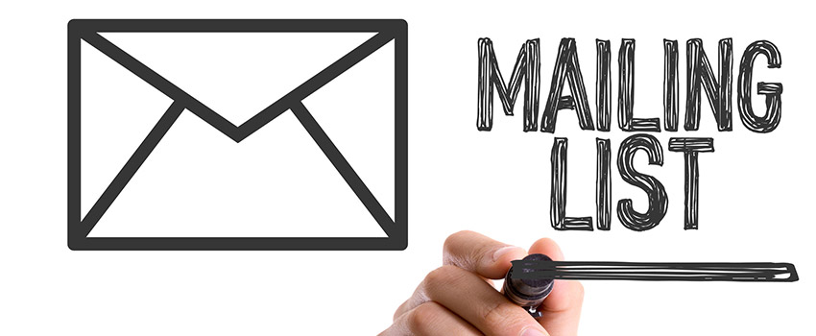

#### WHAT IS DIRECT MAIL?

Direct mail is an integrated marketing strategy that uses a mail service to deliver a custom promotional piece to a carefully selected target audience.

**DIRECT MAIL MARKETING MATERIALS:**

* Brochures
* Catalogs
* Postcards
* Newsletters
* Dimensional mailers
* Flyers

#### DIRECT MAIL / DIGITAL WORLD

When used effectively, direct mail is an integral marketing tactic for connecting and building your business and brand awareness to your customers.

The key to achieving success through direct mail marketing in a rapidly growing digital world is a multi-channel approach; making the most of your marketing dollars!

**Are you ready for your marketing to start getting the attention it deserves?**





1*2*345678**ABC 0-VWXYZ 98765



Adrian Hodges

2400 Juniper Drive

Saginaw, MI 48603



#### WHAT IS DIRECT MAIL?

Direct mail is an integrated marketing strategy that uses a mail service to deliver a custom promotional piece to a carefully selected target audience.

**DIRECT MAIL MARKETING MATERIALS:**

* Brochures
* Catalogs
* Postcards
* Newsletters
* Dimensional mailers
* Flyers

#### DIRECT MAIL / DIGITAL WORLD

When used effectively, direct mail is an integral marketing tactic for connecting and building your business and brand awareness to your customers.

The key to achieving success through direct mail marketing in a rapidly growing digital world is a multi-channel approach; making the most of your marketing dollars!

**Are you ready for your marketing to start getting the attention it deserves?**

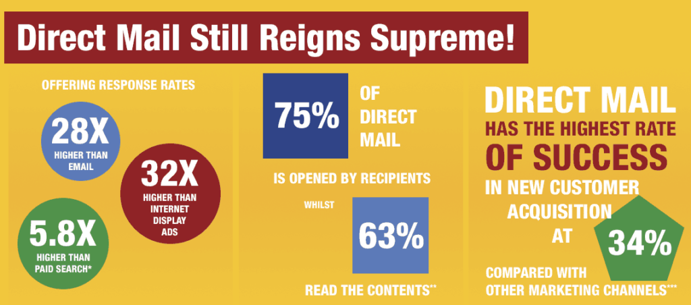





1*2*345678**ABC 0-VWXYZ 98765



Deirdre Baker

335 Meadowcrest Lane

Lexington, KY 40507



#### WHAT IS DIRECT MAIL?

Direct mail is an integrated marketing strategy that uses a mail service to deliver a custom promotional piece to a carefully selected target audience.

**DIRECT MAIL MARKETING MATERIALS:**

* Brochures
* Catalogs
* Postcards
* Newsletters
* Dimensional mailers
* Flyers

#### DIRECT MAIL / DIGITAL WORLD

When used effectively, direct mail is an integral marketing tactic for connecting and building your business and brand awareness to your customers.

The key to achieving success through direct mail marketing in a rapidly growing digital world is a multi-channel approach; making the most of your marketing dollars!

**Are you ready for your marketing to start getting the attention it deserves?**





1*2*345678**ABC 0-VWXYZ 98765



Felicia Carr

3635 Charla Lane

Richardson, TX 75081



#### WHAT IS DIRECT MAIL?

Direct mail is an integrated marketing strategy that uses a mail service to deliver a custom promotional piece to a carefully selected target audience.

**DIRECT MAIL MARKETING MATERIALS:**

* Brochures
* Catalogs
* Postcards
* Newsletters
* Dimensional mailers
* Flyers

#### DIRECT MAIL / DIGITAL WORLD

When used effectively, direct mail is an integral marketing tactic for connecting and building your business and brand awareness to your customers.

The key to achieving success through direct mail marketing in a rapidly growing digital world is a multi-channel approach; making the most of your marketing dollars!

**Are you ready for your marketing to start getting the attention it deserves?**





1*2*345678**ABC 0-VWXYZ 98765



Blake Graham III

3211 Timberbrook Lane

Durango, CO 81301



#### WHAT IS DIRECT MAIL?

Direct mail is an integrated marketing strategy that uses a mail service to deliver a custom promotional piece to a carefully selected target audience.

**DIRECT MAIL MARKETING MATERIALS:**

* Brochures
* Catalogs
* Postcards
* Newsletters
* Dimensional mailers
* Flyers

#### DIRECT MAIL / DIGITAL WORLD

When used effectively, direct mail is an integral marketing tactic for connecting and building your business and brand awareness to your customers.

The key to achieving success through direct mail marketing in a rapidly growing digital world is a multi-channel approach; making the most of your marketing dollars!

**Are you ready for your marketing to start getting the attention it deserves?**







1*2*345678**ABC 0-VWXYZ 98765



Clark Kent

344 Clinton St., Apt. #3B

Metropolis, IL 62960



#### WHAT IS DIRECT MAIL?

Direct mail is an integrated marketing strategy that uses a mail service to deliver a custom promotional piece to a carefully selected target audience.

**DIRECT MAIL MARKETING MATERIALS:**

* Brochures
* Catalogs
* Postcards
* Newsletters
* Dimensional mailers
* Flyers

#### DIRECT MAIL / DIGITAL WORLD

When used effectively, direct mail is an integral marketing tactic for connecting and building your business and brand awareness to your customers.

The key to achieving success through direct mail marketing in a rapidly growing digital world is a multi-channel approach; making the most of your marketing dollars!

**Are you ready for your marketing to start getting the attention it deserves?**







1*2*345678**ABC 0-VWXYZ 98765



Irene Churchill

1331 Spring Street

Springfield, IL 62701



#### WHAT IS DIRECT MAIL?

Direct mail is an integrated marketing strategy that uses a mail service to deliver a custom promotional piece to a carefully selected target audience.

**DIRECT MAIL MARKETING MATERIALS:**

* Brochures
* Catalogs
* Postcards
* Newsletters
* Dimensional mailers
* Flyers

#### DIRECT MAIL / DIGITAL WORLD

When used effectively, direct mail is an integral marketing tactic for connecting and building your business and brand awareness to your customers.

The key to achieving success through direct mail marketing in a rapidly growing digital world is a multi-channel approach; making the most of your marketing dollars!

**Are you ready for your marketing to start getting the attention it deserves?**





1*2*345678**ABC 0-VWXYZ 98765



Jan Dickins

2012 Haven Lane

Dewitt, MI 48820



#### WHAT IS DIRECT MAIL?

Direct mail is an integrated marketing strategy that uses a mail service to deliver a custom promotional piece to a carefully selected target audience.

**DIRECT MAIL MARKETING MATERIALS:**

* Brochures
* Catalogs
* Postcards
* Newsletters
* Dimensional mailers
* Flyers

#### DIRECT MAIL / DIGITAL WORLD

When used effectively, direct mail is an integral marketing tactic for connecting and building your business and brand awareness to your customers.

The key to achieving success through direct mail marketing in a rapidly growing digital world is a multi-channel approach; making the most of your marketing dollars!

**Are you ready for your marketing to start getting the attention it deserves?**





1*2*345678**ABC 0-VWXYZ 98765



Bruce Wayne

1007 Mountain Drive

Gotham, NY 12207



#### WHAT IS DIRECT MAIL?

Direct mail is an integrated marketing strategy that uses a mail service to deliver a custom promotional piece to a carefully selected target audience.

**DIRECT MAIL MARKETING MATERIALS:**

* Brochures
* Catalogs
* Postcards
* Newsletters
* Dimensional mailers
* Flyers

#### DIRECT MAIL / DIGITAL WORLD

When used effectively, direct mail is an integral marketing tactic for connecting and building your business and brand awareness to your customers.

The key to achieving success through direct mail marketing in a rapidly growing digital world is a multi-channel approach; making the most of your marketing dollars!

**Are you ready for your marketing to start getting the attention it deserves?**







1*2*345678**ABC 0-VWXYZ 98765



Kylie Edmunds

2874 Par Drive

Burbank, CA 91504



#### WHAT IS DIRECT MAIL?

Direct mail is an integrated marketing strategy that uses a mail service to deliver a custom promotional piece to a carefully selected target audience.

**DIRECT MAIL MARKETING MATERIALS:**

* Brochures
* Catalogs
* Postcards
* Newsletters
* Dimensional mailers
* Flyers

#### DIRECT MAIL / DIGITAL WORLD

When used effectively, direct mail is an integral marketing tactic for connecting and building your business and brand awareness to your customers.

The key to achieving success through direct mail marketing in a rapidly growing digital world is a multi-channel approach; making the most of your marketing dollars!

**Are you ready for your marketing to start getting the attention it deserves?**





1*2*345678**ABC 0-VWXYZ 98765



Boris Rees V

4579 Sumner Street

Rancho Dominguez, CA 90220



#### WHAT IS DIRECT MAIL?

Direct mail is an integrated marketing strategy that uses a mail service to deliver a custom promotional piece to a carefully selected target audience.

**DIRECT MAIL MARKETING MATERIALS:**

* Brochures
* Catalogs
* Postcards
* Newsletters
* Dimensional mailers
* Flyers

#### DIRECT MAIL / DIGITAL WORLD

When used effectively, direct mail is an integral marketing tactic for connecting and building your business and brand awareness to your customers.

The key to achieving success through direct mail marketing in a rapidly growing digital world is a multi-channel approach; making the most of your marketing dollars!

**Are you ready for your marketing to start getting the attention it deserves?**







1*2*345678**ABC 0-VWXYZ 98765



Colin Peake IV

2462 Fire Access Road

Greensboro, NC 27410



#### WHAT IS DIRECT MAIL?

Direct mail is an integrated marketing strategy that uses a mail service to deliver a custom promotional piece to a carefully selected target audience.

**DIRECT MAIL MARKETING MATERIALS:**

* Brochures
* Catalogs
* Postcards
* Newsletters
* Dimensional mailers
* Flyers

#### DIRECT MAIL / DIGITAL WORLD

When used effectively, direct mail is an integral marketing tactic for connecting and building your business and brand awareness to your customers.

The key to achieving success through direct mail marketing in a rapidly growing digital world is a multi-channel approach; making the most of your marketing dollars!

**Are you ready for your marketing to start getting the attention it deserves?**







1*2*345678**ABC 0-VWXYZ 98765



Erik Greene

4443 Jones Street

Cleburne, TX 76031



#### WHAT IS DIRECT MAIL?

Direct mail is an integrated marketing strategy that uses a mail service to deliver a custom promotional piece to a carefully selected target audience.

**DIRECT MAIL MARKETING MATERIALS:**

* Brochures
* Catalogs
* Postcards
* Newsletters
* Dimensional mailers
* Flyers

#### DIRECT MAIL / DIGITAL WORLD

When used effectively, direct mail is an integral marketing tactic for connecting and building your business and brand awareness to your customers.

The key to achieving success through direct mail marketing in a rapidly growing digital world is a multi-channel approach; making the most of your marketing dollars!

**Are you ready for your marketing to start getting the attention it deserves?**







1*2*345678**ABC 0-VWXYZ 98765



Frank Gordon

3631 Bond Street

Providence, RI 02909



#### WHAT IS DIRECT MAIL?

Direct mail is an integrated marketing strategy that uses a mail service to deliver a custom promotional piece to a carefully selected target audience.

**DIRECT MAIL MARKETING MATERIALS:**

* Brochures
* Catalogs
* Postcards
* Newsletters
* Dimensional mailers
* Flyers

#### DIRECT MAIL / DIGITAL WORLD

When used effectively, direct mail is an integral marketing tactic for connecting and building your business and brand awareness to your customers.

The key to achieving success through direct mail marketing in a rapidly growing digital world is a multi-channel approach; making the most of your marketing dollars!

**Are you ready for your marketing to start getting the attention it deserves?**







1*2*345678**ABC 0-VWXYZ 98765



Madeleine Glover

669 Ferguson Street

Brockton, MA 02401



#### WHAT IS DIRECT MAIL?

Direct mail is an integrated marketing strategy that uses a mail service to deliver a custom promotional piece to a carefully selected target audience.

**DIRECT MAIL MARKETING MATERIALS:**

* Brochures
* Catalogs
* Postcards
* Newsletters
* Dimensional mailers
* Flyers

#### DIRECT MAIL / DIGITAL WORLD

When used effectively, direct mail is an integral marketing tactic for connecting and building your business and brand awareness to your customers.

The key to achieving success through direct mail marketing in a rapidly growing digital world is a multi-channel approach; making the most of your marketing dollars!

**Are you ready for your marketing to start getting the attention it deserves?**





1*2*345678**ABC 0-VWXYZ 98765



Penelope Gray

1934 Red Maple Drive

Mira Loma, CA 91752



#### WHAT IS DIRECT MAIL?

Direct mail is an integrated marketing strategy that uses a mail service to deliver a custom promotional piece to a carefully selected target audience.

**DIRECT MAIL MARKETING MATERIALS:**

* Brochures
* Catalogs
* Postcards
* Newsletters
* Dimensional mailers
* Flyers

#### DIRECT MAIL / DIGITAL WORLD

When used effectively, direct mail is an integral marketing tactic for connecting and building your business and brand awareness to your customers.

The key to achieving success through direct mail marketing in a rapidly growing digital world is a multi-channel approach; making the most of your marketing dollars!

**Are you ready for your marketing to start getting the attention it deserves?**





1*2*345678**ABC 0-VWXYZ 98765



Sonia Hart

849 Romines Mill Road

Dallas, TX 75202



#### WHAT IS DIRECT MAIL?

Direct mail is an integrated marketing strategy that uses a mail service to deliver a custom promotional piece to a carefully selected target audience.

**DIRECT MAIL MARKETING MATERIALS:**

* Brochures
* Catalogs
* Postcards
* Newsletters
* Dimensional mailers
* Flyers

#### DIRECT MAIL / DIGITAL WORLD

When used effectively, direct mail is an integral marketing tactic for connecting and building your business and brand awareness to your customers.

The key to achieving success through direct mail marketing in a rapidly growing digital world is a multi-channel approach; making the most of your marketing dollars!

**Are you ready for your marketing to start getting the attention it deserves?**





1*2*345678**ABC 0-VWXYZ 98765



Victoria Defanda

4523 Victoria Court

Portland, ME 04101



#### WHAT IS DIRECT MAIL?

Direct mail is an integrated marketing strategy that uses a mail service to deliver a custom promotional piece to a carefully selected target audience.

**DIRECT MAIL MARKETING MATERIALS:**

* Brochures
* Catalogs
* Postcards
* Newsletters
* Dimensional mailers
* Flyers

#### DIRECT MAIL / DIGITAL WORLD

When used effectively, direct mail is an integral marketing tactic for connecting and building your business and brand awareness to your customers.

The key to achieving success through direct mail marketing in a rapidly growing digital world is a multi-channel approach; making the most of your marketing dollars!

**Are you ready for your marketing to start getting the attention it deserves?**





1*2*345678**ABC 0-VWXYZ 98765



Wanda Cosmos

248 Spring Haven Trail

Newark, NJ 07102



#### WHAT IS DIRECT MAIL?

Direct mail is an integrated marketing strategy that uses a mail service to deliver a custom promotional piece to a carefully selected target audience.

**DIRECT MAIL MARKETING MATERIALS:**

* Brochures
* Catalogs
* Postcards
* Newsletters
* Dimensional mailers
* Flyers

#### DIRECT MAIL / DIGITAL WORLD

When used effectively, direct mail is an integral marketing tactic for connecting and building your business and brand awareness to your customers.

The key to achieving success through direct mail marketing in a rapidly growing digital world is a multi-channel approach; making the most of your marketing dollars!

**Are you ready for your marketing to start getting the attention it deserves?**





1*2*345678**ABC 0-VWXYZ 98765



Hanji Zoe

255 Shinobe Lane

Denver, CO 80202



#### WHAT IS DIRECT MAIL?

Direct mail is an integrated marketing strategy that uses a mail service to deliver a custom promotional piece to a carefully selected target audience.

**DIRECT MAIL MARKETING MATERIALS:**

* Brochures
* Catalogs
* Postcards
* Newsletters
* Dimensional mailers
* Flyers

#### DIRECT MAIL / DIGITAL WORLD

When used effectively, direct mail is an integral marketing tactic for connecting and building your business and brand awareness to your customers.

The key to achieving success through direct mail marketing in a rapidly growing digital world is a multi-channel approach; making the most of your marketing dollars!

**Are you ready for your marketing to start getting the attention it deserves?**





1*2*345678**ABC 0-VWXYZ 98765



Leonard Hofstadter

3211 North Los Robles Avenue, Apt. # 4B

Pasadena, CA 91101



#### WHAT IS DIRECT MAIL?

Direct mail is an integrated marketing strategy that uses a mail service to deliver a custom promotional piece to a carefully selected target audience.

**DIRECT MAIL MARKETING MATERIALS:**

* Brochures
* Catalogs
* Postcards
* Newsletters
* Dimensional mailers
* Flyers

#### DIRECT MAIL / DIGITAL WORLD

When used effectively, direct mail is an integral marketing tactic for connecting and building your business and brand awareness to your customers.

The key to achieving success through direct mail marketing in a rapidly growing digital world is a multi-channel approach; making the most of your marketing dollars!

**Are you ready for your marketing to start getting the attention it deserves?**







1*2*345678**ABC 0-VWXYZ 98765



Phoenix Wright

12345 N Taliesin Drive

Scottsdale, AZ 85259



#### WHAT IS DIRECT MAIL?

Direct mail is an integrated marketing strategy that uses a mail service to deliver a custom promotional piece to a carefully selected target audience.

**DIRECT MAIL MARKETING MATERIALS:**

* Brochures
* Catalogs
* Postcards
* Newsletters
* Dimensional mailers
* Flyers

#### DIRECT MAIL / DIGITAL WORLD

When used effectively, direct mail is an integral marketing tactic for connecting and building your business and brand awareness to your customers.

The key to achieving success through direct mail marketing in a rapidly growing digital world is a multi-channel approach; making the most of your marketing dollars!

**Are you ready for your marketing to start getting the attention it deserves?**







1*2*345678**ABC 0-VWXYZ 98765



Yvonne Ogden

3949 Stadium Drive

Framingham, MA 01702



#### WHAT IS DIRECT MAIL?

Direct mail is an integrated marketing strategy that uses a mail service to deliver a custom promotional piece to a carefully selected target audience.

**DIRECT MAIL MARKETING MATERIALS:**

* Brochures
* Catalogs
* Postcards
* Newsletters
* Dimensional mailers
* Flyers

#### DIRECT MAIL / DIGITAL WORLD

When used effectively, direct mail is an integral marketing tactic for connecting and building your business and brand awareness to your customers.

The key to achieving success through direct mail marketing in a rapidly growing digital world is a multi-channel approach; making the most of your marketing dollars!

**Are you ready for your marketing to start getting the attention it deserves?**





1*2*345678**ABC 0-VWXYZ 98765



Una King

1487 Tripple Road

Philadelphia, PA 19111



#### WHAT IS DIRECT MAIL?

Direct mail is an integrated marketing strategy that uses a mail service to deliver a custom promotional piece to a carefully selected target audience.

**DIRECT MAIL MARKETING MATERIALS:**

* Brochures
* Catalogs
* Postcards
* Newsletters
* Dimensional mailers
* Flyers

#### DIRECT MAIL / DIGITAL WORLD

When used effectively, direct mail is an integral marketing tactic for connecting and building your business and brand awareness to your customers.

The key to achieving success through direct mail marketing in a rapidly growing digital world is a multi-channel approach; making the most of your marketing dollars!

**Are you ready for your marketing to start getting the attention it deserves?**





1*2*345678**ABC 0-VWXYZ 98765



Sheldon Cooper

3211 North Los Robles Avenue, Apt. # 4A

Pasadena, CA 91101



#### WHAT IS DIRECT MAIL?

Direct mail is an integrated marketing strategy that uses a mail service to deliver a custom promotional piece to a carefully selected target audience.

**DIRECT MAIL MARKETING MATERIALS:**

* Brochures
* Catalogs
* Postcards
* Newsletters
* Dimensional mailers
* Flyers

#### DIRECT MAIL / DIGITAL WORLD

When used effectively, direct mail is an integral marketing tactic for connecting and building your business and brand awareness to your customers.

The key to achieving success through direct mail marketing in a rapidly growing digital world is a multi-channel approach; making the most of your marketing dollars!

**Are you ready for your marketing to start getting the attention it deserves?**

